TjopTjop
The health screening app for schools, businesses and malls
powered by the North-West University, South Africa

Installation instructions
- Open any web browser and navigate to www.tjop-tjop.com.
- Click on the Sign Up link and complete the information in full so that your invoice will be generated correctly.
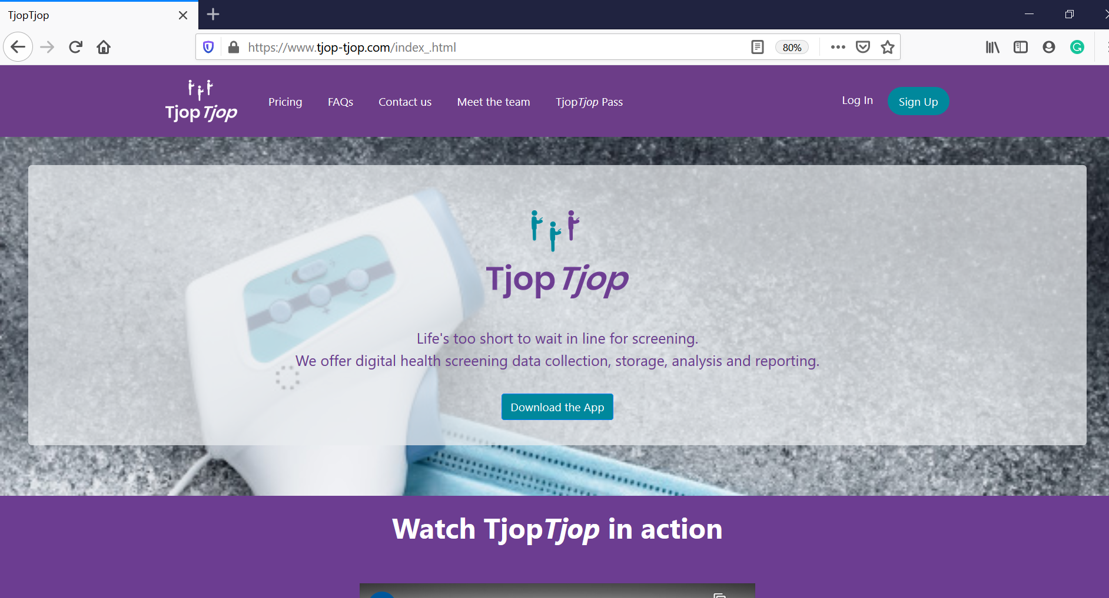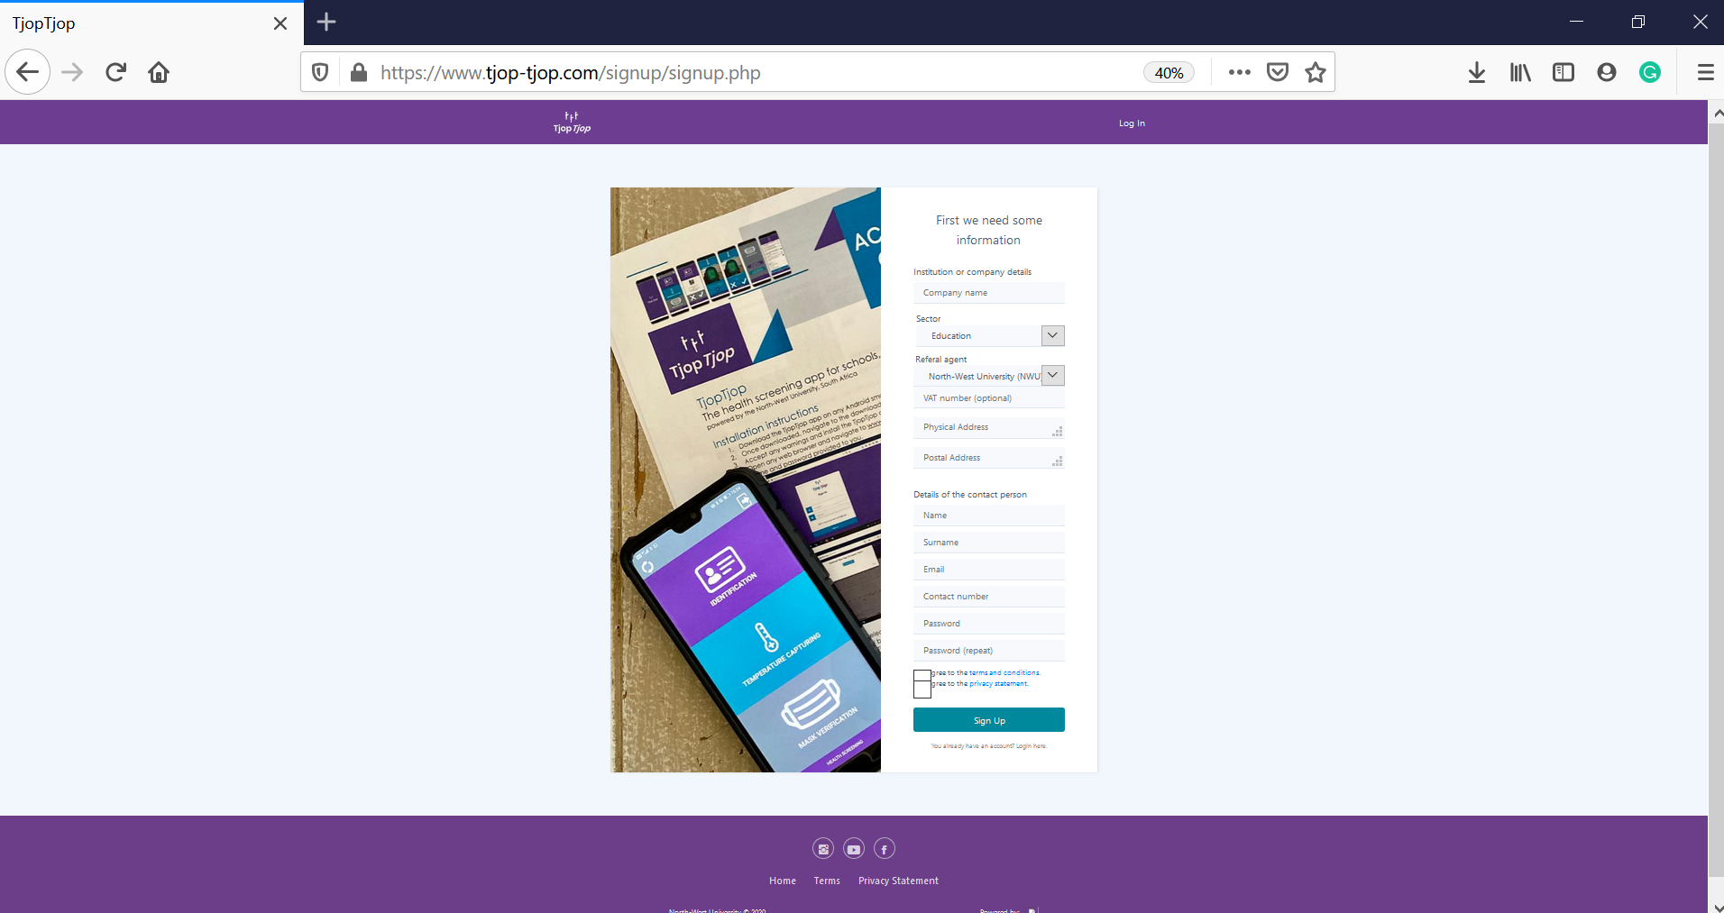

- To verify your account, please follow the link which will automatically be sent to your email address.
- You will receive another email from us as soon as your account has been verified.
- Create your user groups and upload your user information (Menu item: User Groups) (if you are either an educational institution or a business that would like to create and use QR-based ID cards for your staff). If you are a business and will use government ID cards or booklets (not license cards) as identification token, you can skip this step.
- Complete the payment process using Payments menu item. Please note that a “generate token” button needed to acticate your app will only appear after you have successfully made a payment. If this button does not appear within 30 minutes of you making a payment on payfast, please send your proof of payment to contact@tjoptjop.info for a manual override.
- Download the TjopTjop app on any Android smartphone using the link on www.tjop-tjop.com.
- Once downloaded on your phone, navigate to the downloaded file and open the file.
- Accept any warnings and install the TjopTjop app.
- You can install the app on as many cell phones as you like and follow the connection instruction below to link them to your site.

Activating the app to connect to the web portal
- Open any web browser and to www.tjop-tjop.com and enter the login details you created.
- Once logged in, select the menu option and generate a new token. Take note of the token generated as it will be used to log into the TjopTjop app on a phone.

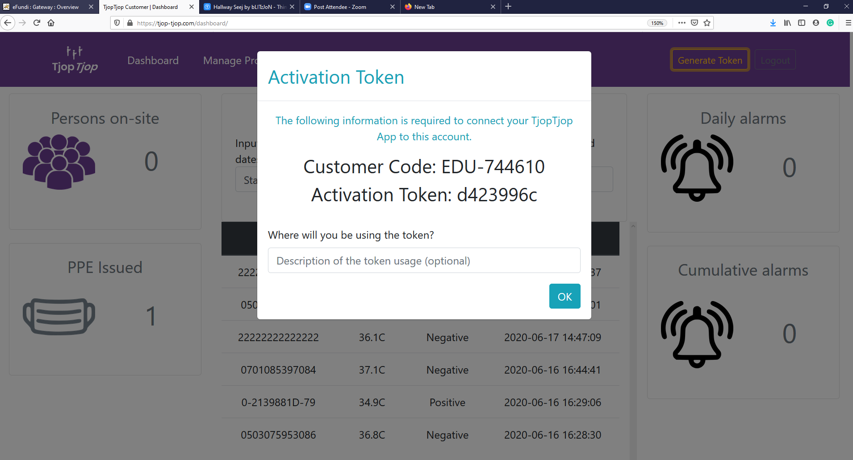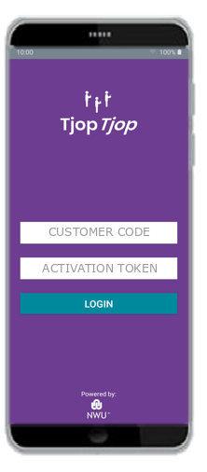

- Now open the TjopTjop app and enter the customer code and the token you just generated.
- You can repeat this process for as many cell phones as you want for your site, noting that all the data captured with that device with your token combination will be stored as the data of your institution.

Registering users
- Remember to add your users in groups to ease your monitoring on the portal and for billing purposes (you will be billed for the entire group if any user in that group is scanned for the first time – keep this in mind for phased arrivals.
- Still on the web portal www.tjop-tjop.com, navigate to User groups, and select new group.

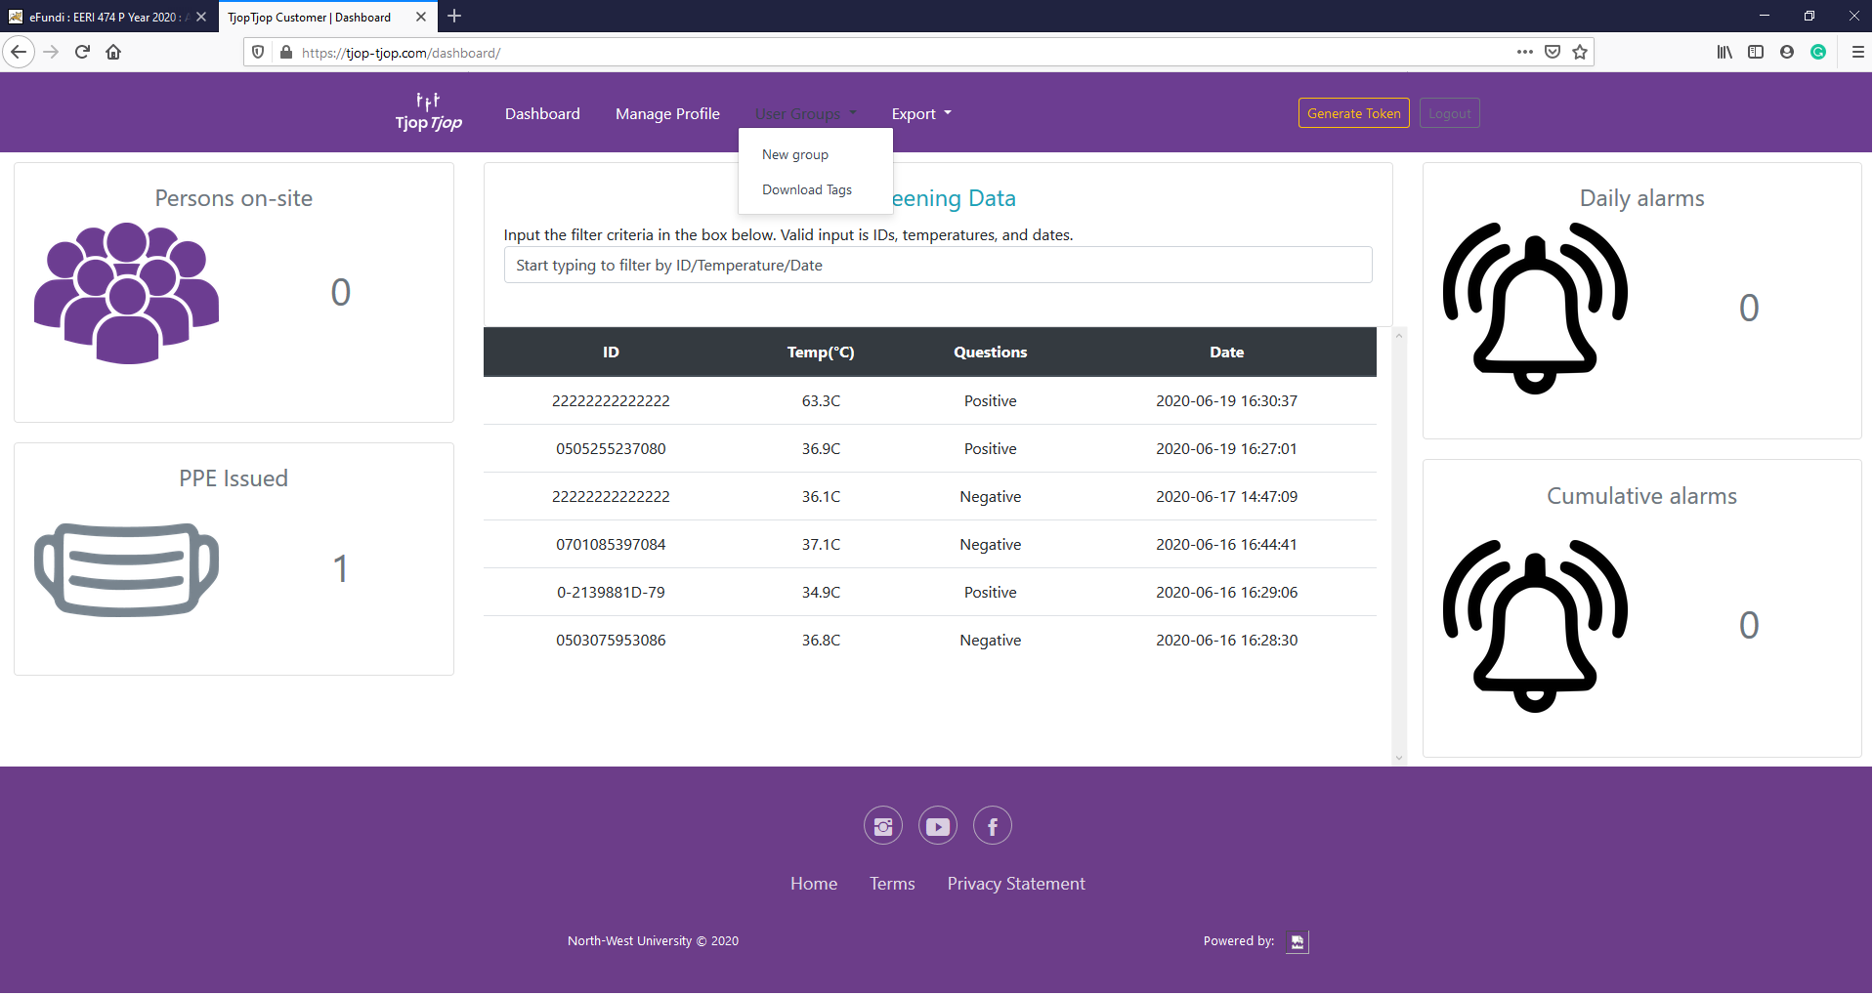

- Follow the prompts provided on the pop-up screen - This tool helps you to upload the required information to generate QR tags. You'll need to provide the information in a Microsoft Excel spreadsheet similar to the example shown in the image below. You'll be guided through the process step by step. (Please note: The first row must contain the column names and leave unused columns empty)

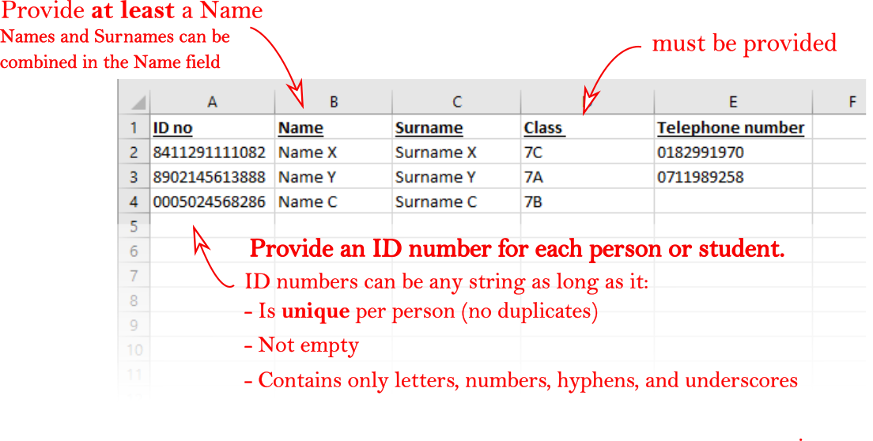

- You can download a sample excel file from the pop-up window.
- Now browse to the location where you stored the Excel file and then select Upload File

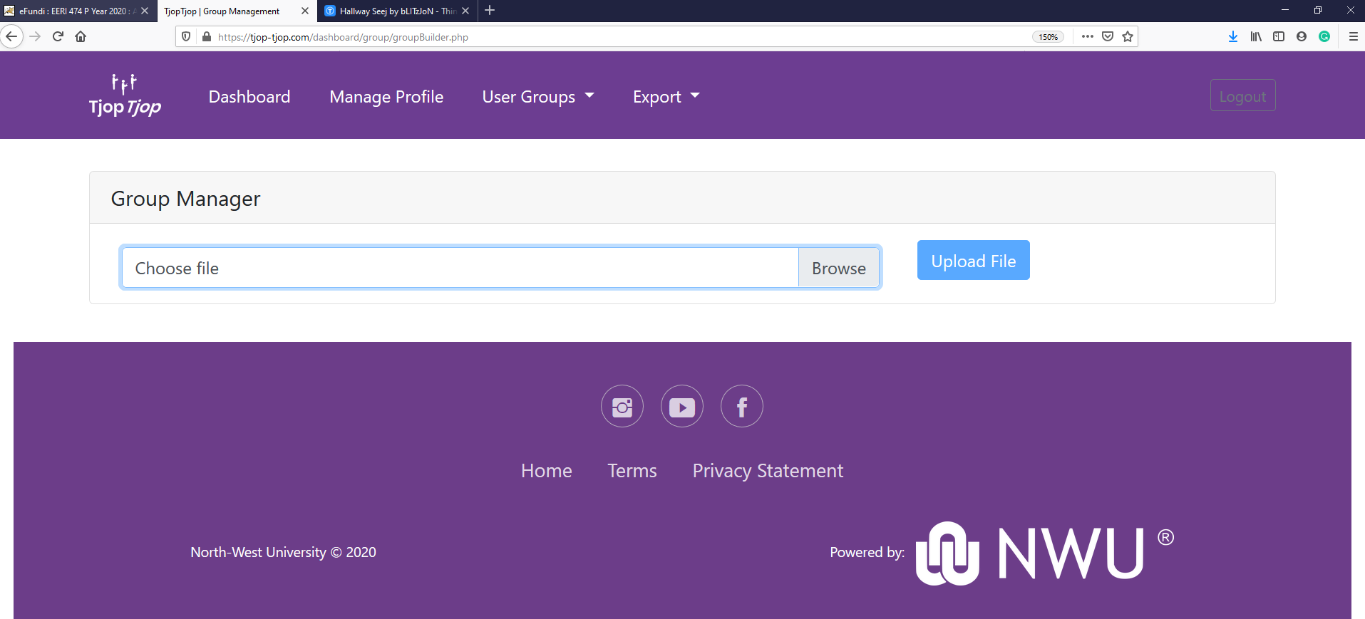

- Next, give a descriptive name for that group – It can be a specific grade or class, or a department of which you would like to see the grouped screening results of, and select Create.

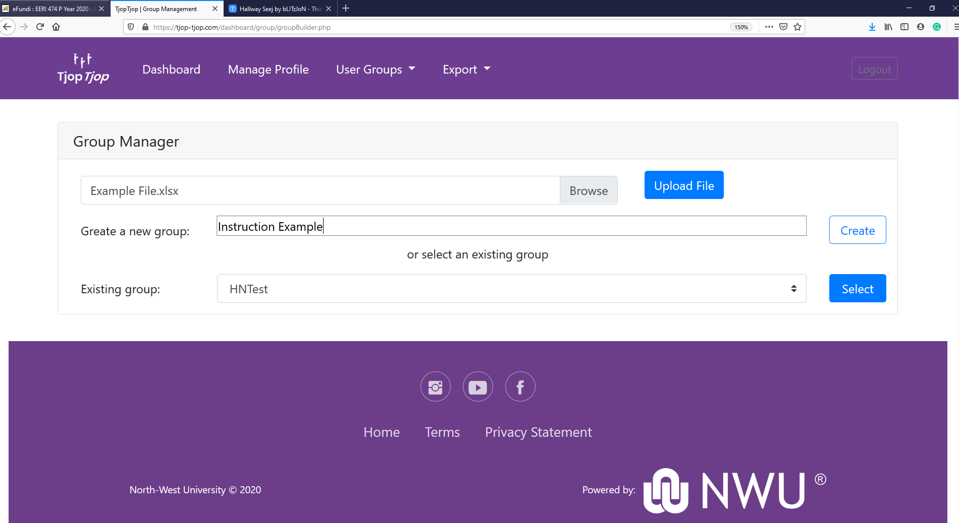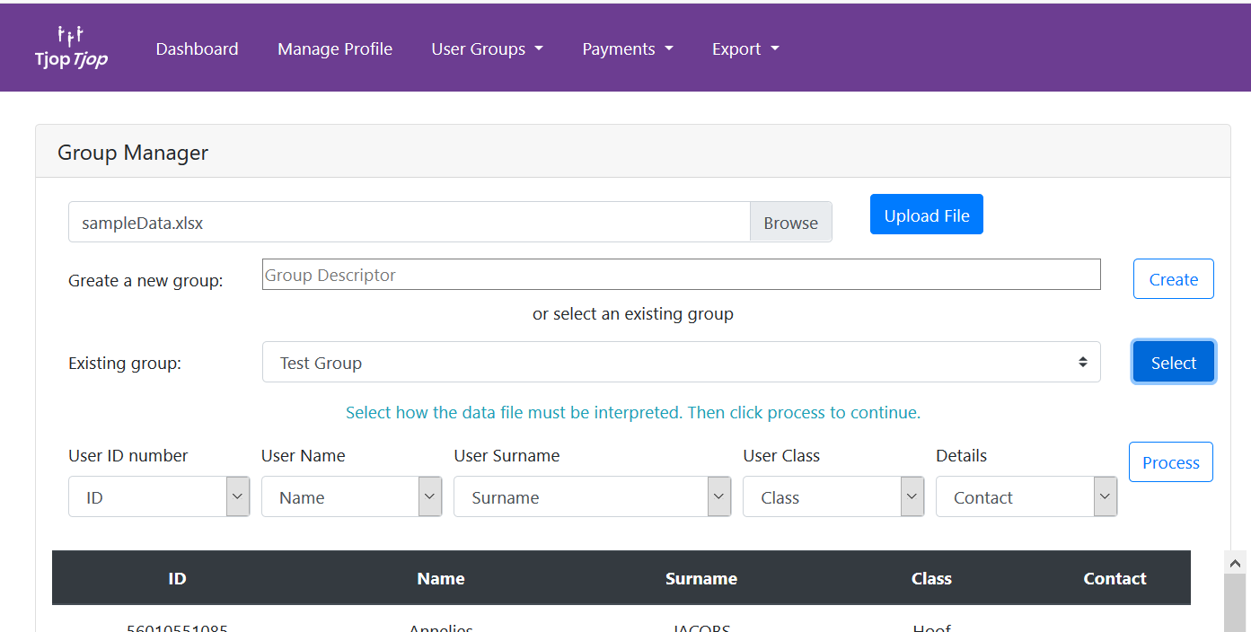

- Now, select that group from the Existing Groups list and select Process.
- Finally select SAVE DATA.
- Your ID cards will be generated within 24 hours of your submission.
- Once your ID cards are ready, you’ll be able to download them from the User Groups >> Download Tags tab.

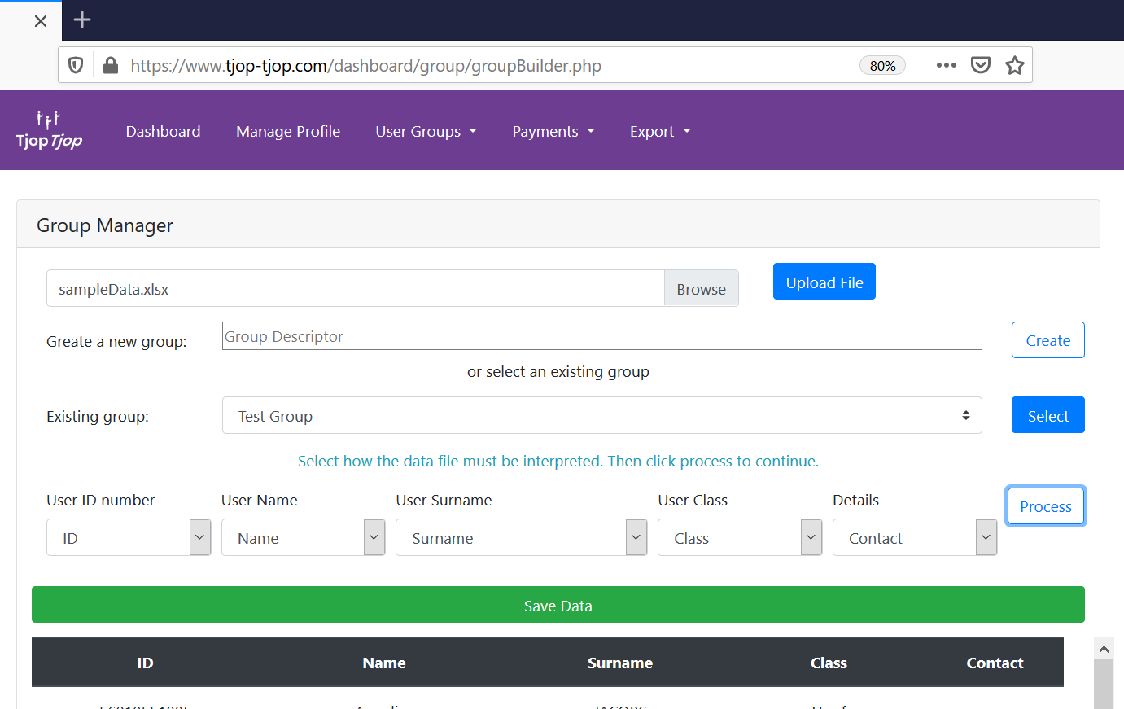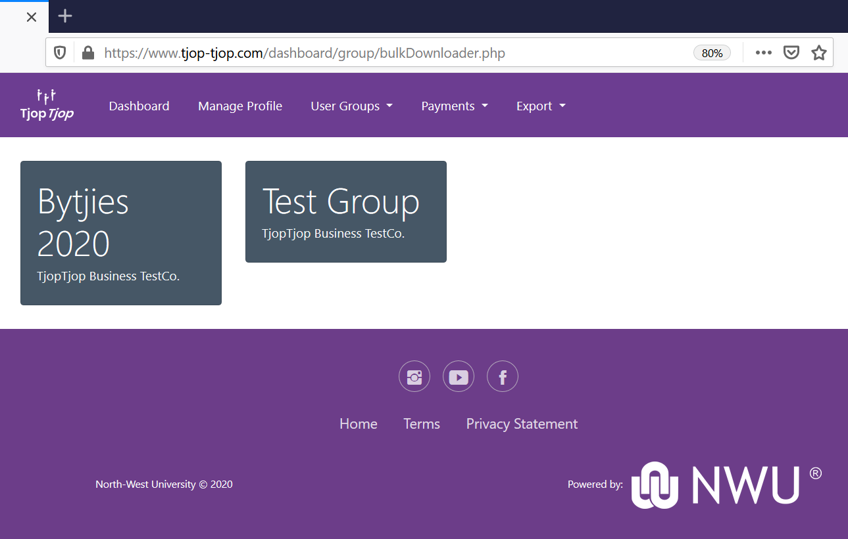

Payment process
- Still on the web portal www.tjop-tjop.com, navigate to Payments, and select Make Payment, which will open the invoice builder.

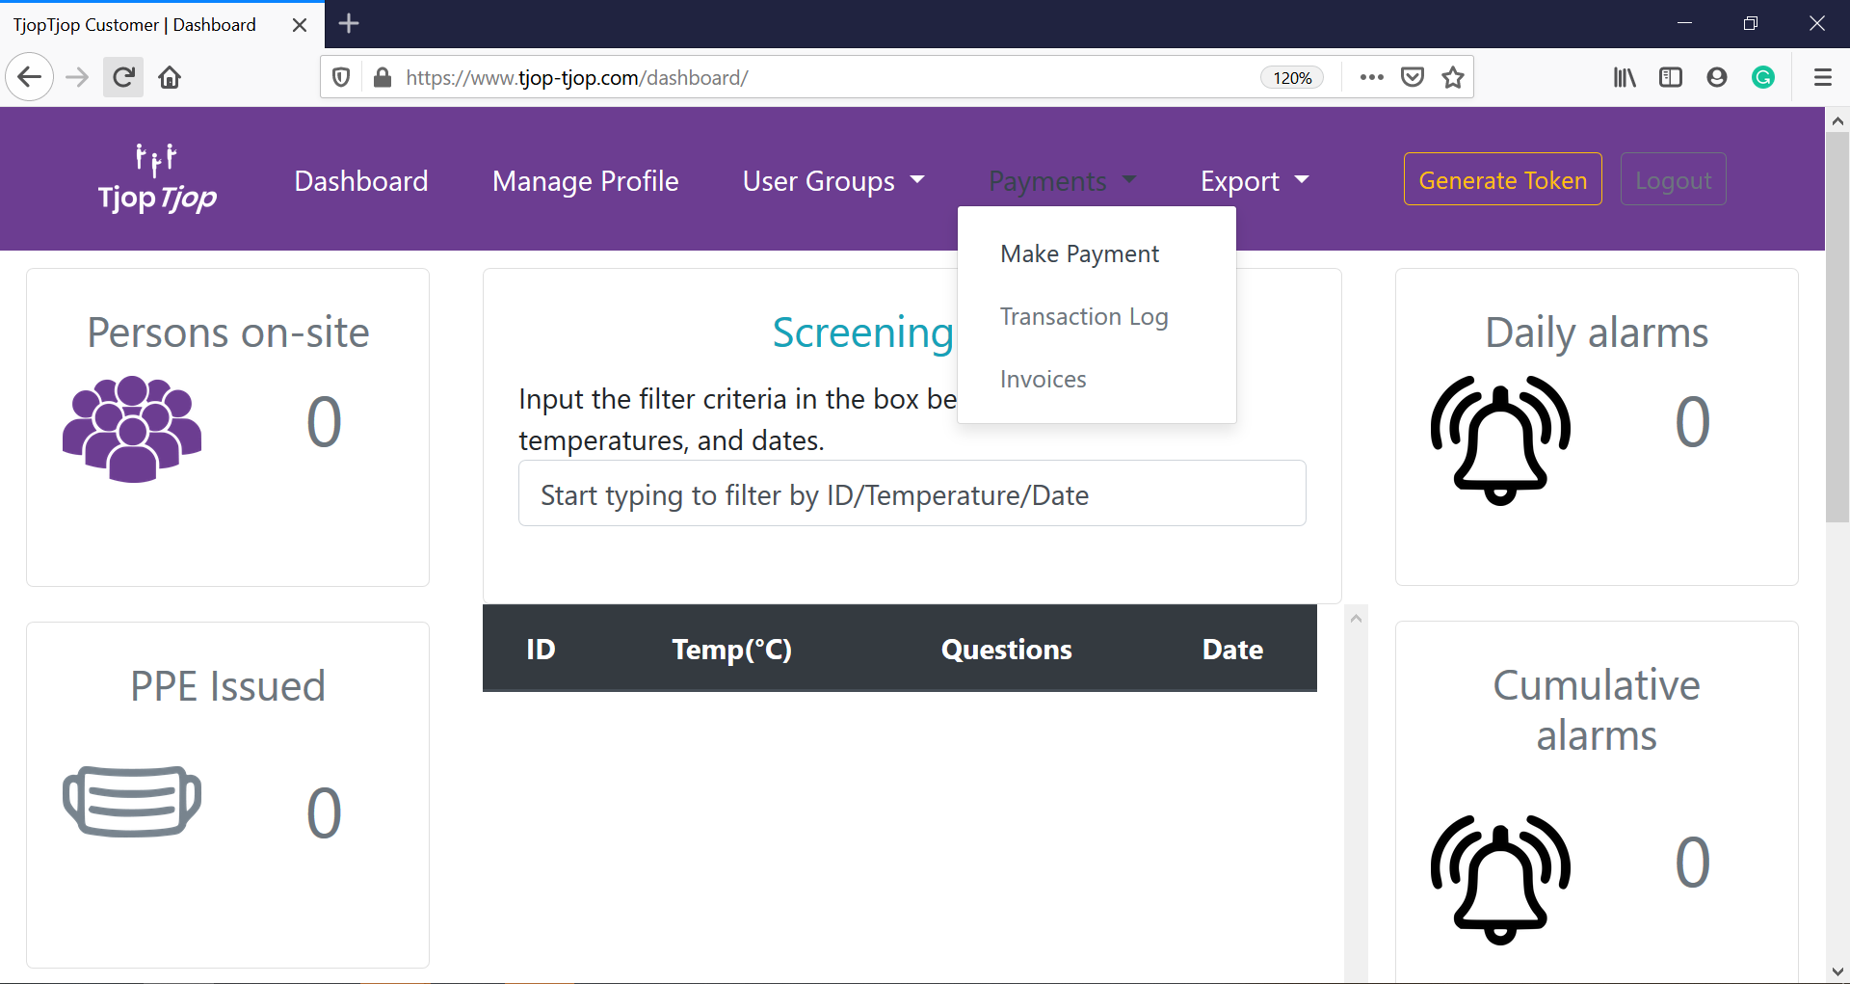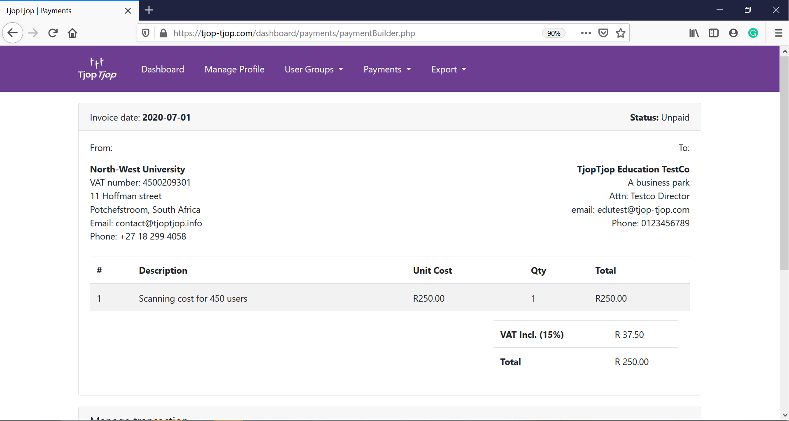

- Note at the bottom of the page that you can choose to just pay the activation fee and admin fee for now, or choose to prepay your scanning fee or admin fees for a number of months in advance. (Remember that educational institution fees are calculated per registered person per month, while businesses are paying per scan). In both cases add your actual numbers – we will automatically subtract the 200 free persons/scans.

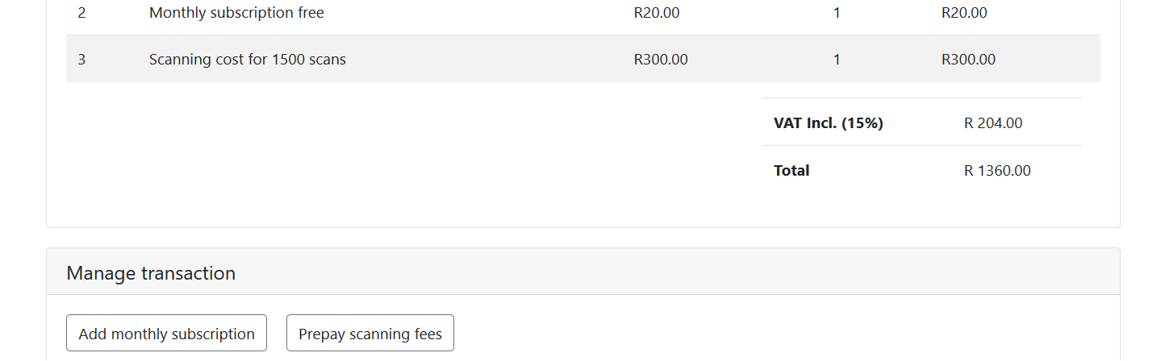
- If you add any additional payments to the list, a “Save details” button will appear. Make sure that you are satisfied with these numbers BEFORE you click ok to save this transaction, since operations cannot be undone!

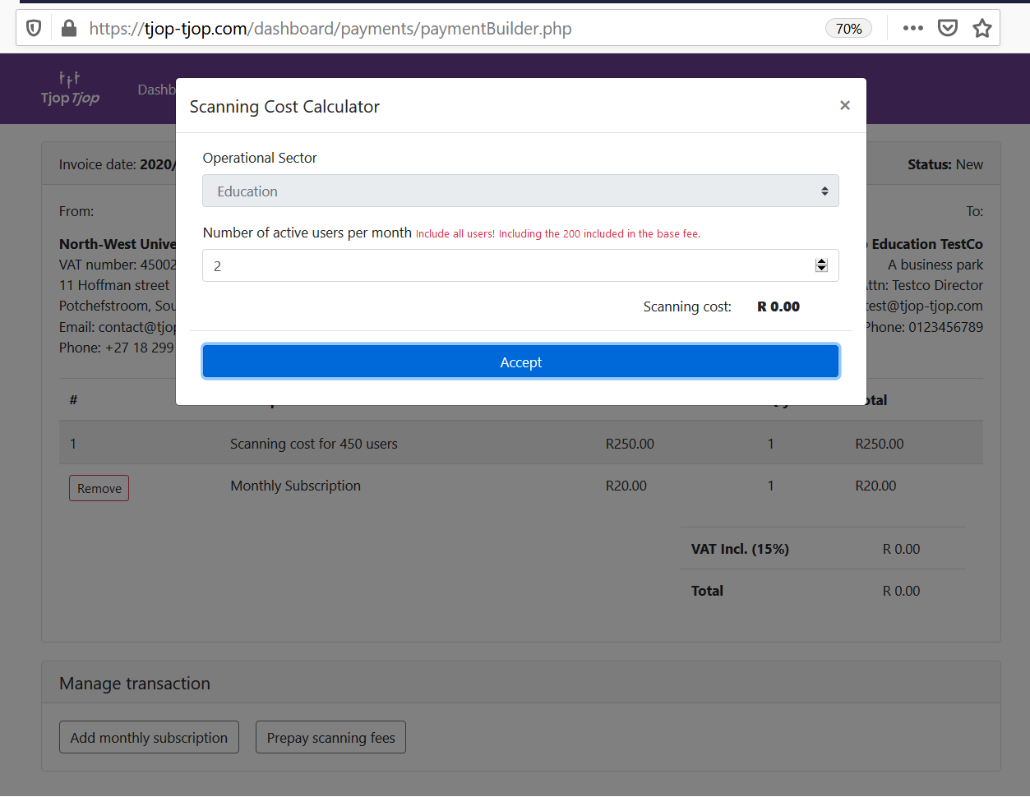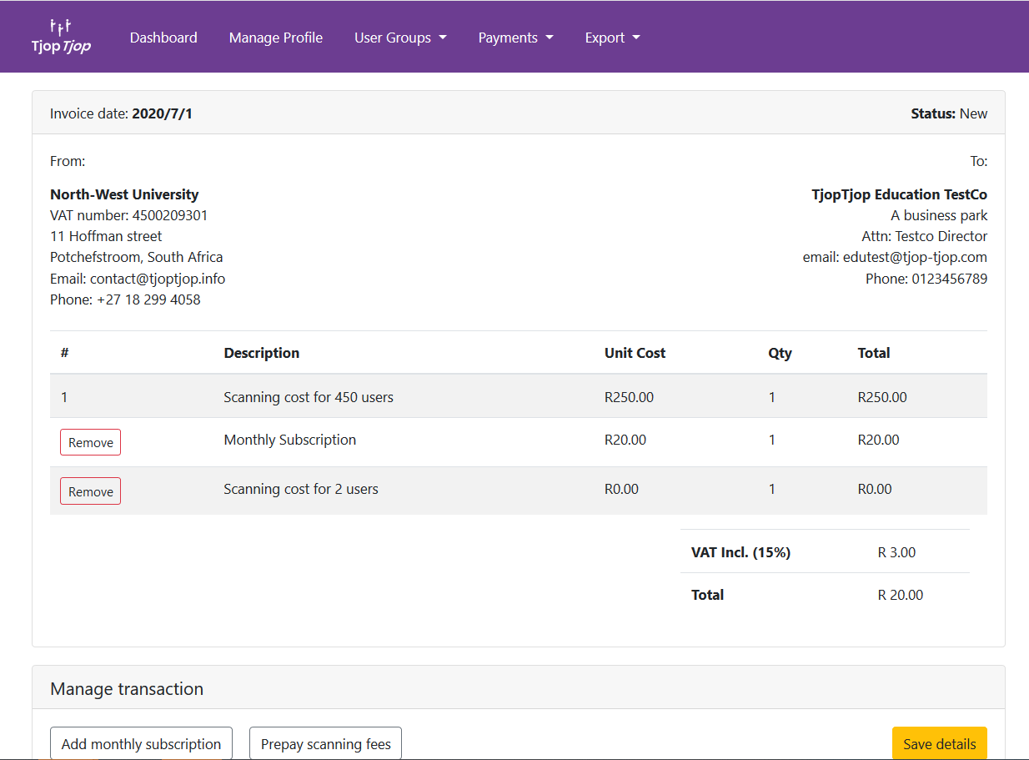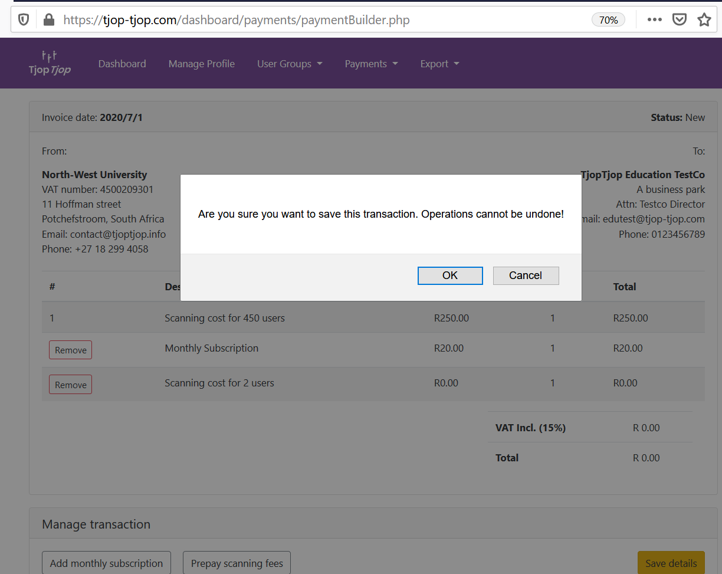

- From here you’llbe taken to the PayFast portal, after which you will automatically receive a proof of payment from PayFast via email. After this, your “Generate Token” button will appear.
Screening process
- On successful login, three options will be provided to complete the screening process namely: Identification, Temperature Capturing and Mask Verification.

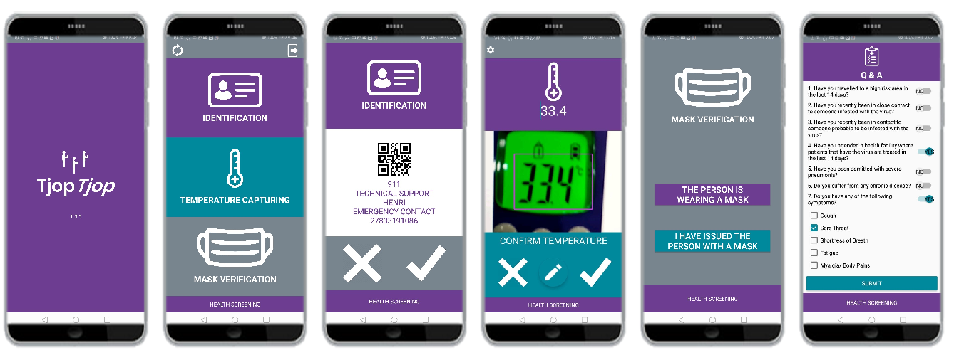

- To complete a screening process, select Identification and capture the QR code of the person being screened. Ensure the QR code is within the outlined rectangle. Verified that the person has been correctly identified. You can use this sample QR to practice with:
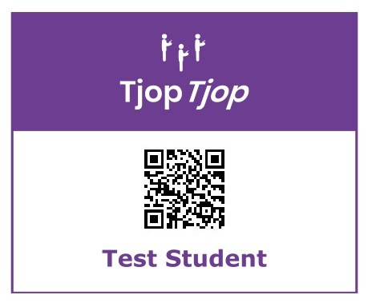
- Next is the Temperature Capturing. Using a digital thermometer capture the temperature of the person being screened. For best results – refer to the section on Temperature capturing below.
- Next verify that the person is wearing a mask or has been issued with a mask.
- Lastly answer the questions provided and click Submit.
  - Note that all the answers are marked as no by default, so you only need to change those sliders where the answer is yes.
- The information captured in the TjopTjop app will be available at www.tjop-tjop.com after you performed a synchronisation action as described later on in this document.

Temperature capturing process
TjopTjop makes extensive use of image processing to accomplish large parts of the screening process. Although, image processing has improved significantly the performance of such systems remain highly dependent on the quality of the input image.

TjopTjop makes use of images to identify a person (either by QR or barcode) and also to automatically determine the temperature displayed on a common Infrared thermometer. Examples of these types of thermometers are displayed in the image below.

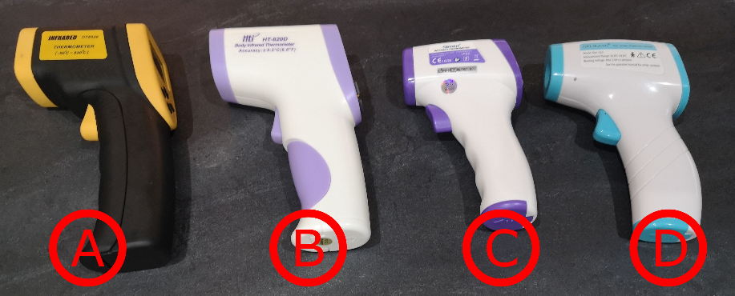
Figure 1: Example of common infra-red thermometers

Meter A in the figure is not suitable for medical use and is only included as a general reference.
All of the other meters feature a display that has digits that are all equal in height and have good contrast with the background.

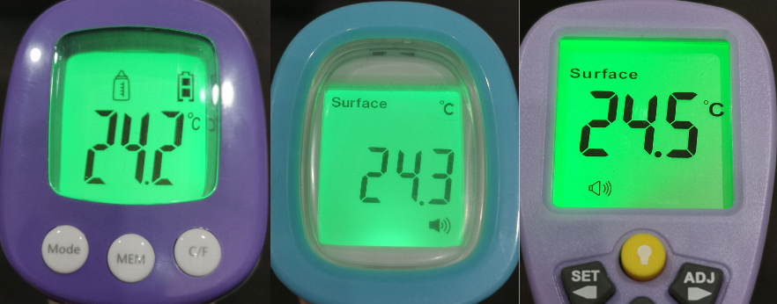
Figure 2: Example of thermometer B,C,D's displays

In cases where the background colour and that of the digits are too similar, the accuracy of automatically detected temperature will suffer. An example of such a display is provided in Figure 3 note that the size of the digits are also not constant and the that background colour and the text is not as different as the example text in Figure 2.

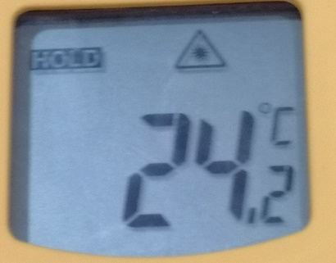
Figure 3: Example of an unsupported screen

In order to reduce the complexity of automatically detecting where in a photograph the display of the meter is, some help from the operator is required. This is done by the operator positioning the displayed temperature within a frame that is drawn over the image (see below). The area within the frame is referred to as the capture zone.

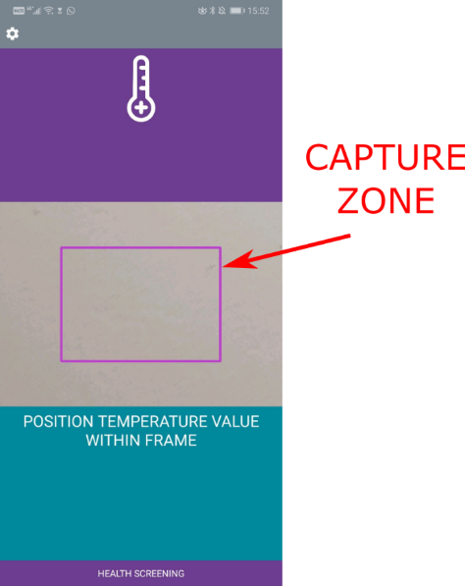
Figure 4: Temperature capture zone
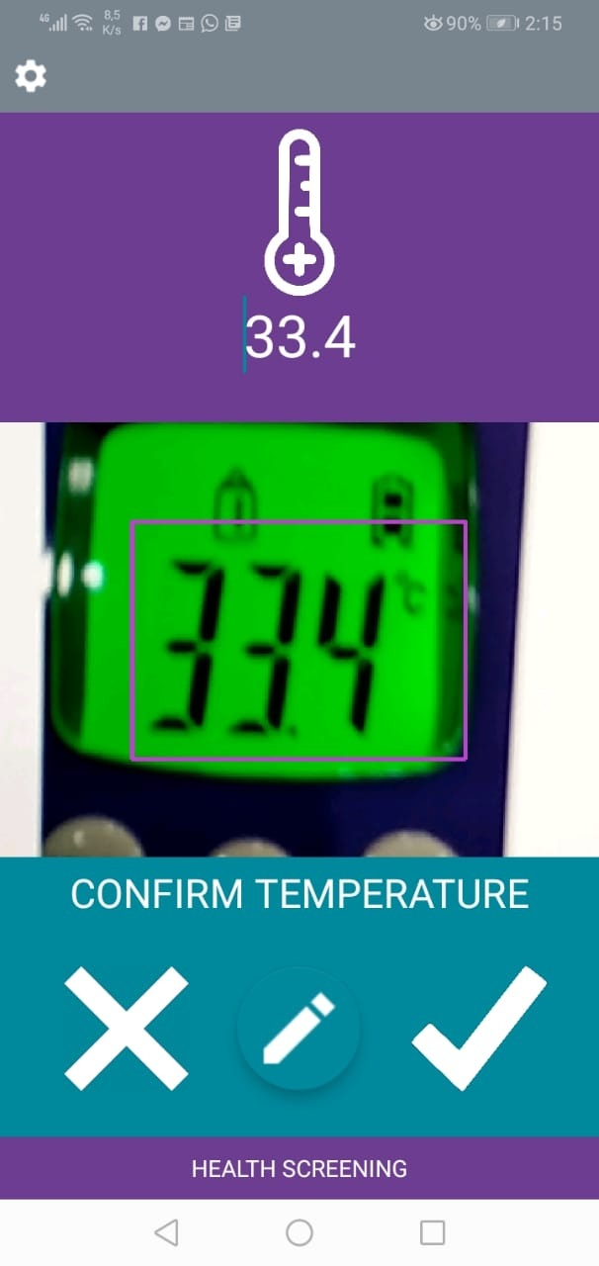
Figure 5: Example of a successfully captured temperature

Once the temperature display has been positioned within the capture zone automatic detection is completed and the temperature is displayed to the operator. The operator can then use the relevant icon to either confirm that the temperature was captured correctly or to repeat the temperature capturing process to capture it correctly.

As mentioned earlier, the quality of the images plays an important role in successful temperature data capturing. Examples images of good quality, acceptable quality, and poor quality input images are provided as a guideline. For poor quality images it is typical that no automatic detection can be done.

Examples of good inputs

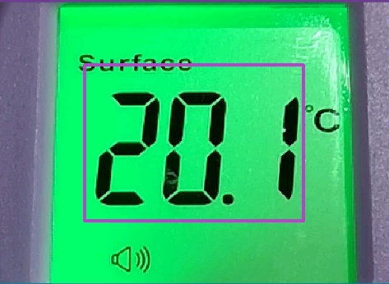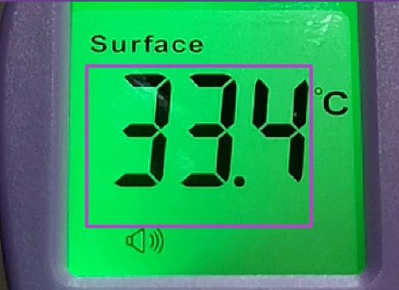
Figure 6: Examples of Good Images

Both images in Figure 6 contain examples of good quality images. Both figures have the temperature reading clearly visible and contained within the capture zone. In such cases the accuracy of the system will be very good.

Examples of acceptable input
The following images are acceptable as input. However, as the image quality deteriorates the performance of the automatic detection will start to suffer. Always try to capture images of high quality.

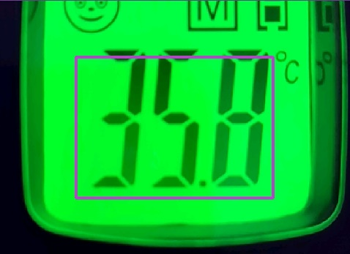
Figure 8: Acceptable A
In Figure 8 the text is mostly within the frame but the top edges are cut off. Since all of the digits are recognisable without the topmost segments classification still succeeds. Had the last digit been a 7 a wrong classification of 1 would have been made (since a 7 without the top segment looks like a 1)

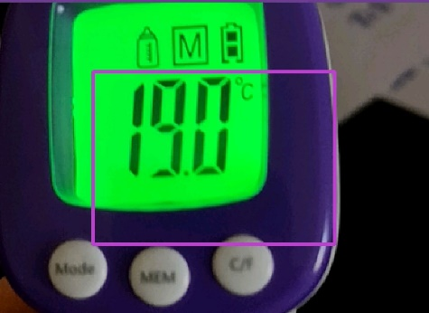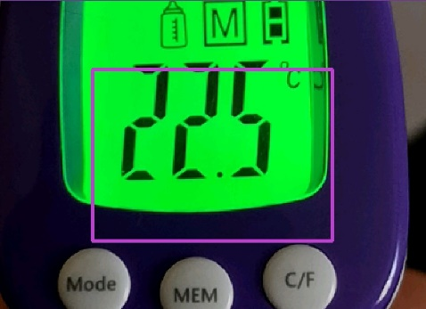
Figure 9: Acceptable B
Even though the automatic detection is performed correctly for both images in Figure 9 the output is not positioned optimally within the frame. Since classification performance will suffer this situation should, ideally, be avoided.

Examples of poor input images

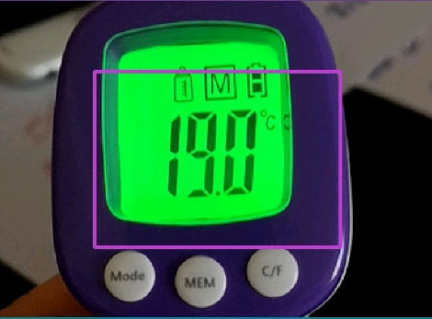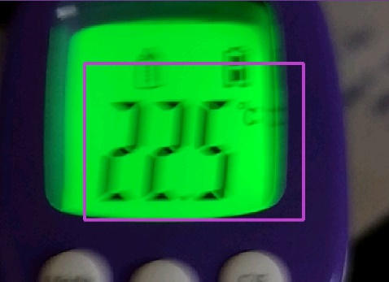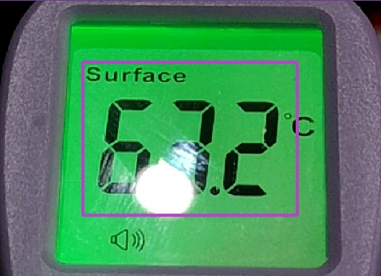
Figure 10: Examples of poor images

In Figure 10 several examples of poor quality images are provided. The far left image contains much more of the thermometer frame than it should. The centre image is significantly blurred (however, some blurring is acceptable) and the image to the far right contains a glare spot from an overhead light source. With all of these images classification results cannot be guaranteed.

Manual temperature entry
If you choose not to use the automatic temperature capturing option, you can click on the pencil icon and type in the temperature manually.

Data synchronisation process
- After each screening entry, the data is stored on the phone and a network connection is therefore not needed at the screening station.
- Once the data collection device (cell phone) is connected to the internet, please perform a synchronisation operation to transfer the data from the phone to the web portal.
- To synchronise your data, please select the synchronise button (two circular arrows) in the top left corner of the app, and follow the instructions.
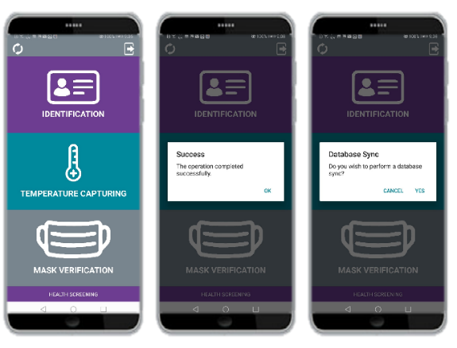

Using the web portal to monitor your site
Once the data synchronisation process was performed, you will be able to browse the collected data for your site at www.tjop-tjop.comusing the same login details as before.
- You can use the search function by typing an ID, date or temperature in the space provided.

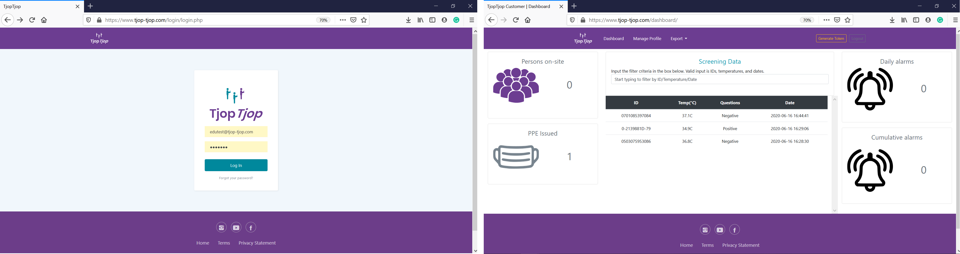

- You can also export the full report of all the data collected for your site using the export .csv button.
- The .csv file can then be processed and printed if you need to.

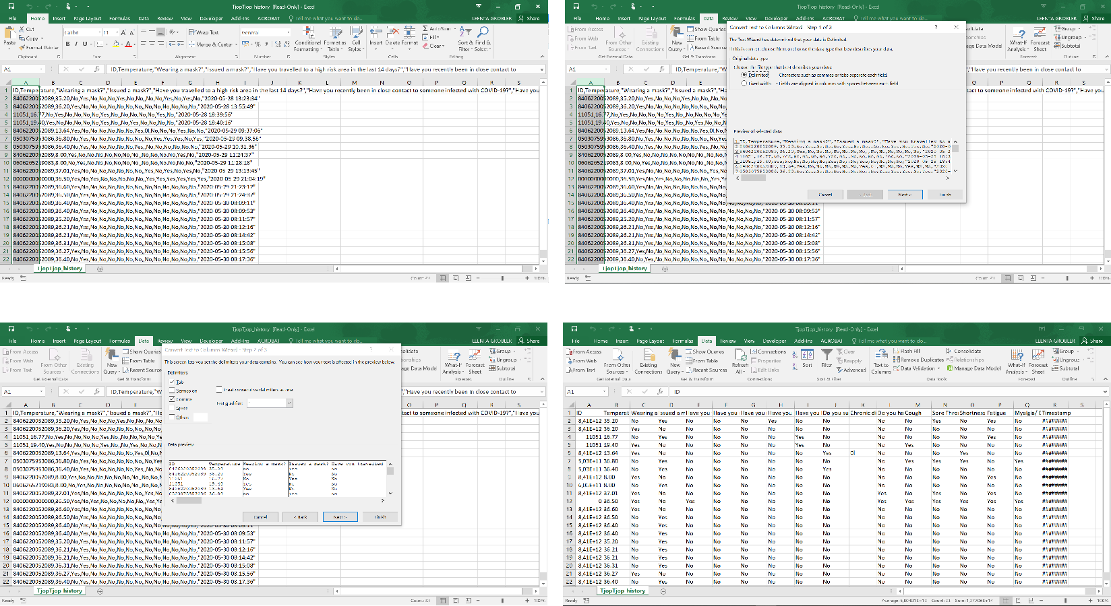

Technical support
If you struggle with any part of this process, call Henri at our technical help desk: +27 83 319 1086

